DEPARTMENT OF ORAL AND MAXILLOFACIAL SURGERY
TAGORE DENTAL COLLEGE AND HOSPITAL
MELAKOTTAIYUR POST, RATHINAMANGALAM
CHENNAI – 600127
PH: 044 – 3010 2222, EXTN: 228 / 230
EMAIL ID: maxfacs@tagoredch.in

PROF.M.MALA PROF.DR.VENKATAKRISHNAN
CHAIRPERSON PRINCIPAL
ORGANIZING COMMITTEE:
PROF.DR.S.JIMSON
DR.B.LOKESH
DR.B.ANANDH
DR.BALAKRISHNA
DR.MEERAN SHARIF
DR.ISRAEL NATHANAEL
DR.JONES JAYABALAN
DR.JEDIDIAH FREDRICK ABISHEG

Organizer:
Department of Oral & Maxillofacial Surgery
Tagore Dental College & Hospital
Date: 31ST OCTOBER & 1ST NOVEMBER 2021
Learning Outcome:
- To Acquire detailed knowledge about Temporomandibular joint anatomy, different Temporomandibular joint disorders, surgical & non surgical interventions of Temporomandibular Joint Disorders, minimally invasive procedures .
- To train students in arthroscopy procedure.

Guest Speakers:
1. DR. ABHAY TARANATH KAMATH
Senior Consultant
Department of Oral and Maxillofacial Surgery,
Manipal Hospital , Mangalore .

2. DR. NEHAL PATEL

Senior Consultant

Department of Oral and Maxillofacial Surgery
Director at Nuface Dental and Maxillofacial Surgery Clinic
Surat, Gujarat

3. DR.PRAMOD SUBASH

Clinical Professor, Cranio Maxillofacial Surgery.
Amrita Institute of Medical Sciences and Research Centre

Kochi .

4. DR. DR.N.VIVEK

Professor, Dean and HOD
Department of Oral and Maxillofacial Surgery
SRM Kattankulathur Dental College.

5. DR. K. ARUNKUMAR
Associate Professor,
Department of Oral And Maxillofacial Surgery,
Tamil Nadu-Gdch.

6. DR. SENTHILNATHAN. P
Professor & HOD
Department of Oral And Maxillofacial Surgery,
Saveetha Dental College & Hospitals

7. DR. KANNAN BALRAMAN
Senior Consultant
Department Of Oral and Maxillofacial Surgery
Ganga Medical Centre And Hospital

8. DR.K.BALAJI
Professor & HOD
Department Of Orthodontics
Tagore Dental College & Hospital

9. DR.V.RANGARAJAN
Professor & HOD
Department Of Prosthodontics
Sri Venketeswara Dental College & Hospital

TOPICS COVERED:
- DIAGNOSTIC ARTHROSCOPY AND ARTHROSCOPIC SURGERY OF TMJ
- IMAGING IN TMJ DISORDERS
- MYOFACIAL PAIN DYSFUNCTION SYNDROME
- ARTHROCENTESIS
- OPEN TMJ SURGERY
- TEMPOROMANDIBULAR JOINT REPLACEMENT
- NON SURGICAL MANAGEMENT OF TEMPOROMANDIBULAR JOINT DISORDERS

Day 1 - The program started with the welcome speech by Dr.S.Jimson followed by the Principal’ s speech by Dr.C.J.Venkatakrishnan . The felicitation of the faculties of the program were done . Dr.S.Jimson Dr.C.J.Venkatakrishnan & Dr.Kumudha ,Medical Director (TMCH), felicitated the faculties . the first session started by 9.am followed by the other sessions . A Panel discussion between faculties of three different disciplines on was held by 10.30 AM which included Dr.V.Rangarajan from the department of prosthodontics, Dr.Balaji.k, from the department of Orthodontics Dr.Abay T.Kamath from the Department of Oral & Maxillofacial Surgery .it was an intense and highly informative discussion on treatment options for Temporomandibular joint cases and approaches for the same from the respective disciplines .A short break was observed by 11.am .Soon after the break the lectures started by 11.15AM and continued till 12.45 PM. A Conclusive panel discussion on the days topics was conducted from 1.30 to 2.30 PM .
Day 2:The program started with arthroscopy session 1 at 9.00 am and ended at 11.45 am followed by arthroscopy session 2 which started at 11.45 am and concluded by 1.00 pm.The panel discussion was conducted by Dr.Nehal Patel,Dr.PramodSubash, Dr.Abhay T Kamath,Dr.Arun Kumar.k from 1.30-2.00 pm.The day came to an end with the valedictory ceremony from 2.00-2.30pm.

PROGRAM SCHEDULE DAY 1

TIME | PROGRAM | FACULTY
08.30 am -09.00 am | REGISTRATION
09.00 am -09.20 am | EXAMINATION AND DIAGNOSTIC POINTERS | Dr.Nehal Patel
09.20 am -09.40 am | IMAGING IN TMJ DISORDERS | Dr.Pramod Subash
09.40 am -10.00 am | MYOFACIAL PAIN DYSFUNCTION SYNDROME | Dr.Kannan Balaraman
10.00 am -10.30 am | NON SURGICAL MANAGEMENT | Dr.V.Rangarajan  (prosthodontist)
10.30 am -11.00 am | PANEL DISCUSSION(ORTHO/PROS/OMFS) | Dr.V.Rangarajan,  Dr.Balaji.k,  Dr.Abay T. Kamath
11.00 am -11.15 am | BREAK
11.15 am -11.30 am | INTERNAL DERANGEMENT,TMJ ARTHRITIS AND IDIOPATHIC CONDYLAR RESORPTION | Dr.Vivek Narayan
11.30 am -11.45 am | ARTHROSCOPIC SURGERY OF TMJ | Dr.Nehal Patel
11.45 am -12.00 pm | ARTHROCENTESIS | Dr.Senthil Nathan
12.00 pm -12.15 pm | OPEN TMJ SURGERY | Dr.Pramod Subash
12.15 pm -12.30 pm | RECURRENT TMJ DISLOCATION | Dr.Arun Kumar.K
12.30 pm -12.45 pm | TOTAL JOINT REPLACEMENT | Dr.Abhay T Kamath
12.45 pm -01.30 pm | LUNCH
01.30 pm -02.30 pm | CASE/PANEL DISCUSSION

PROGRAM SCHEDULE DAY 2
TIME | PROGRAM | FACULTY
09:00am - 11:45am | ARTHROSCOPY SESSION 1 | Dr.Nehal Patel  Dr.Pramod Subash
11:45am - 01.00pm | ARTHROSCOPY SESSION 2 | Dr.Nehal Patel  Dr.Pramod Subash
01:00pm - 01:30 pm | LUNCH
01:30pm - 02:00pm | PANEL DISCUSSION |  | Dr.Nehal Patel  Dr.Pramod Subash  Dr.Abhay T Kamath  Dr.Arun Kumar.k
02:00pm - 02:30 pm | VALEDICTORY CEREMONY

ATTENDANCE SHEET: TMJD WORKSHOP 31.10.2021 DAY 1
SURESH VEERAMANI | DR. NISARG DESAI | DR CHANDHANA A V
KARTHICK SEKAR | SAKTHISRI V | SAPNA D P SOMANI
DR RAGHVENDRA SINGH NARELA | ACCHUTHAKRISHNAN | DYNA ALBERT
DR MOHAMMED ARSHAD PATHAN | DR. SNEHESH DINESH | VIVEK D MENON
DR.C.TAMIL SELVAN | KILLAMPALLI YASHWANTH VARAHA SATYANARAYANA | SAM JOHN KOSHY
SR ANIL KUMAR DESAI | DR. KALPA PANDYA | P ADITYA REDDY
DR. PRIYANKA BARMAN | DR. PRADEEP. S | SWETHA BHAT
DR. RITUPARNA MITRA | SABARI NATHAN RAJAMOORTHY | SNEHA KRISHNAN
CHANDINI RAVIKUMAR | SUTHAN RAJ | HEMAVATHY KARTHICK
DR. ABHIRAMI SRIKANTH | DR NIRMALA DEVAR | SREEJEE. G
N INBAMANI | MURUGESH | ALDEN SCHNYDER JASON D
JAGADEESHWAR N | DR.PRASANNA GURU.E | DR. RAGAVENDRAN
HARSHITHA RAJ | NITHISH SANKEPALLY | HEMNAATH R
S.M.M.MOULVI | A. BHARGAVI | DR. SURIYA KUMAR N
GURU PRASAD T | ABITHA.V | DR PRIYANKA. S
LAVANYA L | VIJAYKARTHIK JAYARAMAN | GEORGE SAMYO STEPHENSON
NIKITHA | DR. ADITYA HURKAT | N.DEVA KUMAR
MOHAMMED ZUHAIB | MANISHAA. V | N.S.YAZHINI
SAHANA B S | KALYANI P | AVINASH.G
K SAI HITESH | KHANYA A | FELCY A
PEARLCID SIRORAJ | DR.PAVITHRAN.A | AJINKYA NAIK
S MAHIMA | PAVITHRA SARDA | DHANALAKSHMI P
DR B SIVARAGHAVI | DR BHAGYASHREE M | SOYA ALFRED XAVIER

ATTENDANCE SHEET: TMJD WORKSHOP 1.11.2021 DAY 2
SURESH VEERAMANI | DR. NISARG DESAI | DR CHANDHANA A V
KARTHICK SEKAR | SAKTHISRI V | SAPNA D P SOMANI
DR RAGHVENDRA SINGH NARELA | ACCHUTHAKRISHNAN | DYNA ALBERT
DR MOHAMMED ARSHAD PATHAN | DR. SNEHESH DINESH | VIVEK D MENON
DR.C.TAMIL SELVAN | KILLAMPALLI YASHWANTH VARAHA SATYANARAYANA | SAM JOHN KOSHY
SR ANIL KUMAR DESAI | DR. KALPA PANDYA | P ADITYA REDDY
DR. PRIYANKA BARMAN | DR. PRADEEP. S | SWETHA BHAT
DR. RITUPARNA MITRA | SABARI NATHAN RAJAMOORTHY | SNEHA KRISHNAN
CHANDINI RAVIKUMAR | SUTHAN RAJ | HEMAVATHY KARTHICK
DR. ABHIRAMI SRIKANTH | DR NIRMALA DEVAR | SREEJEE. G
N INBAMANI | MURUGESH | ALDEN SCHNYDER JASON D
JAGADEESHWAR N | DR.PRASANNA GURU.E | DR. RAGAVENDRAN
HARSHITHA RAJ | NITHISH SANKEPALLY | HEMNAATH R
S.M.M.MOULVI | A. BHARGAVI | DR. SURIYA KUMAR N
GURU PRASAD T | ABITHA.V | DR PRIYANKA. S
LAVANYA L | VIJAYKARTHIK JAYARAMAN | GEORGE SAMYO STEPHENSON
NIKITHA | DR. ADITYA HURKAT | N.DEVA KUMAR
MOHAMMED ZUHAIB | MANISHAA. V | N.S.YAZHINI
SAHANA B S | KALYANI P | AVINASH.G
K SAI HITESH | KHANYA A | FELCY A
PEARLCID SIRORAJ | DR.PAVITHRAN.A | AJINKYA NAIK
S MAHIMA | PAVITHRA SARDA | DHANALAKSHMI P
DR B SIVARAGHAVI | DR BHAGYASHREE M | SOYA ALFRED XAVIER

ATTENDANCE PERCENTAGE:
PROGRAM FEEDBACK:

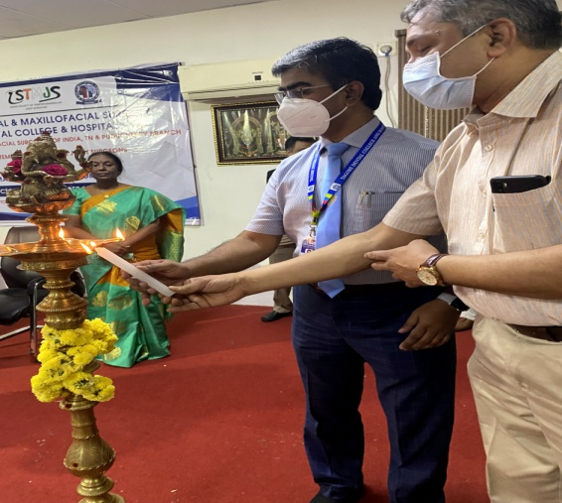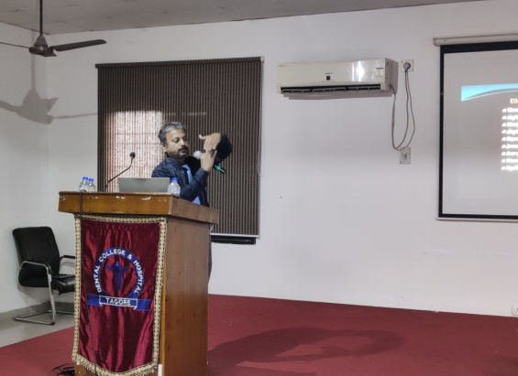
INAUGRATION CEREMONY SEMINARS

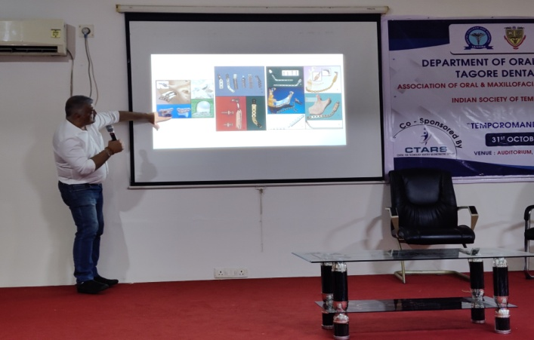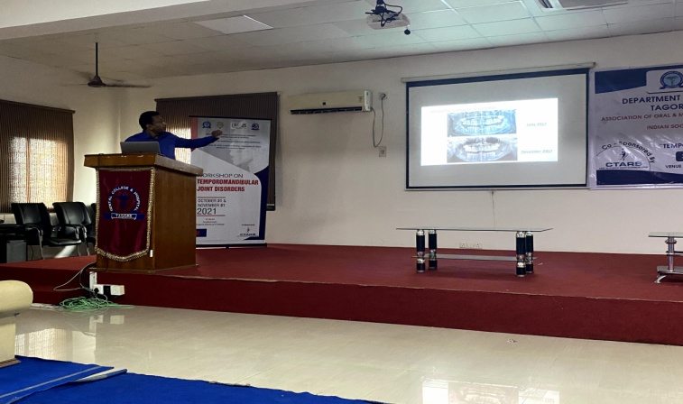
TOPICS BEING EXPLAINED IN DETAIL BY DR.ABAY T.KAMAT

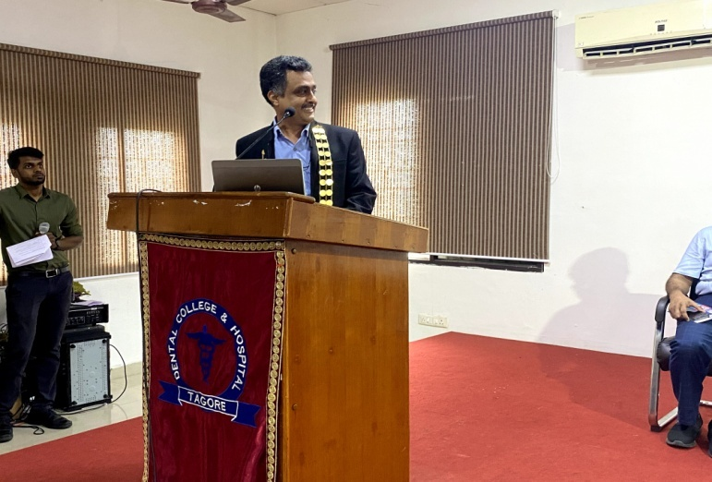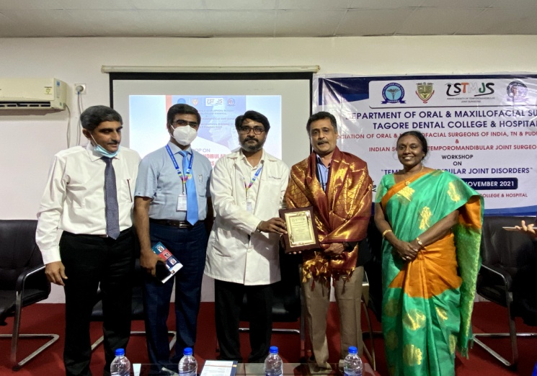
SPEECH GIVEN BY DR.VEERABAHU PRESIDENT,AOMSI FELICITATION CEREMONY
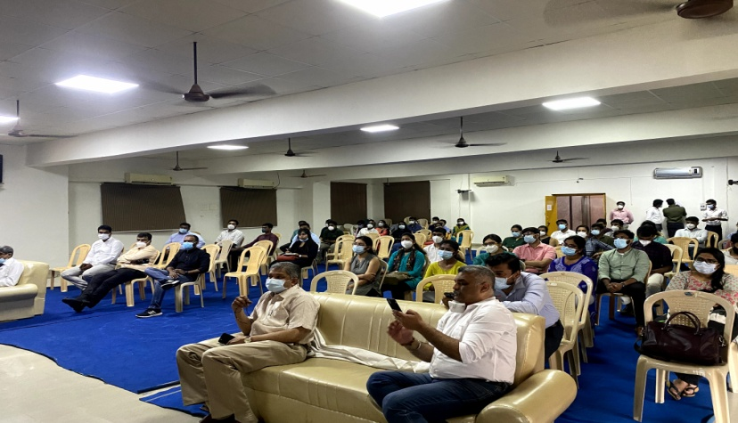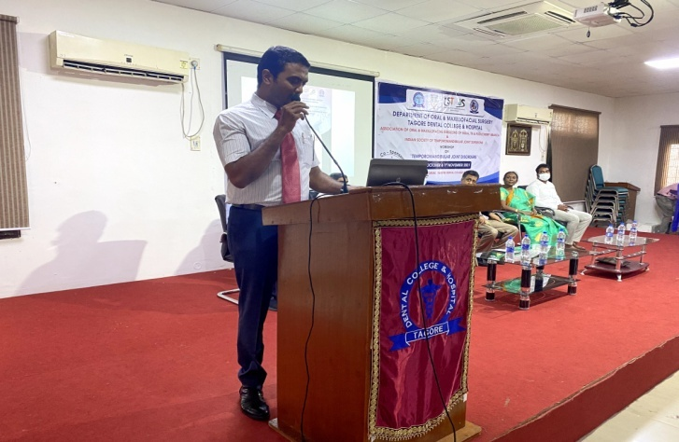
PARTICIPANTS AT THE TMD WORK SHOP WELCOME SPEECH BY DR.ANANDH
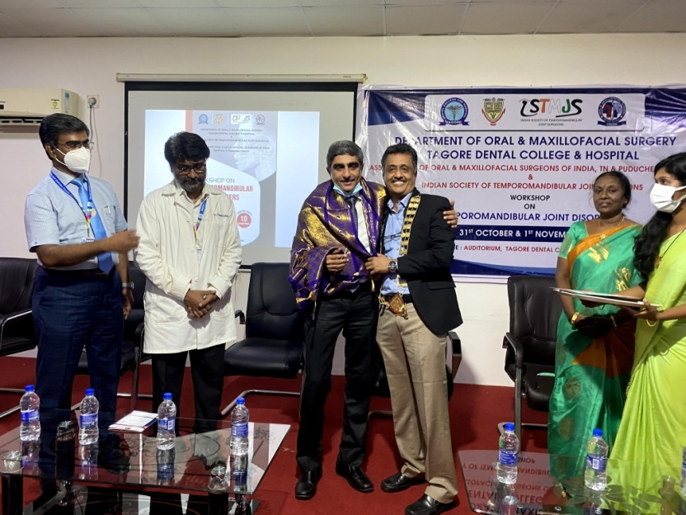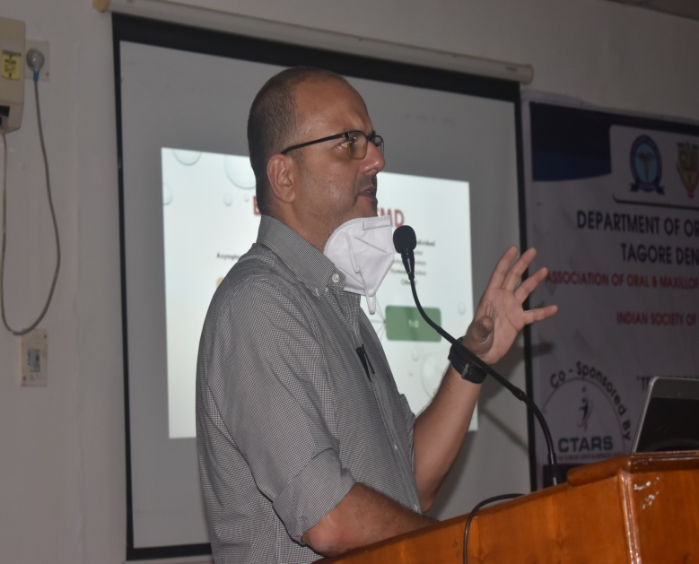
FELICITATION DR.NEHAL PATEL SEMINAR
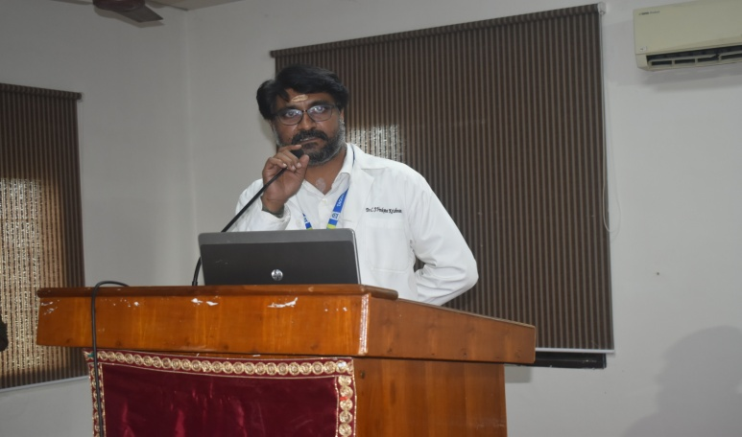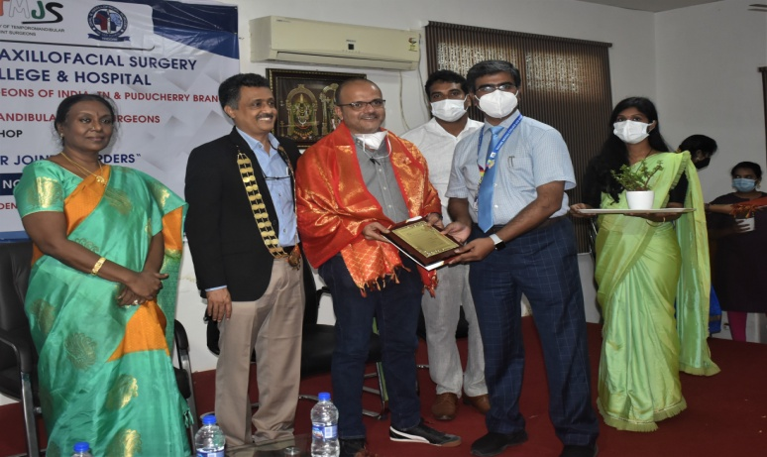
SPEECH GIVEN BY DR.VENKETALRISHNAN FELICITATION
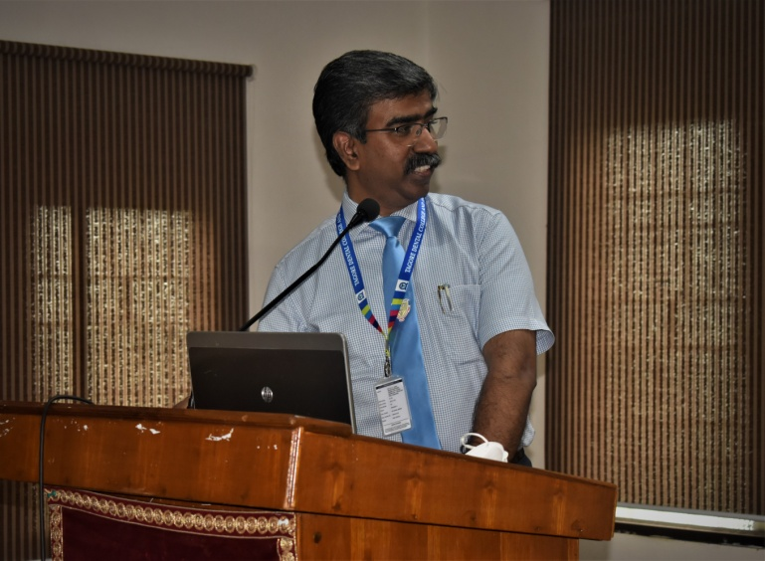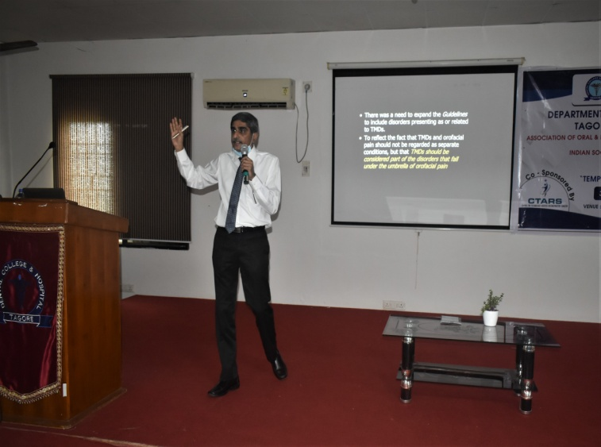
SPEECH BY DR.JIMSON SEMINAR BY DR.RANGARAJAN
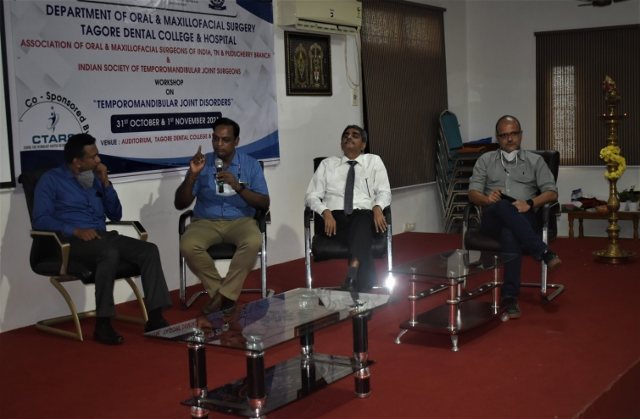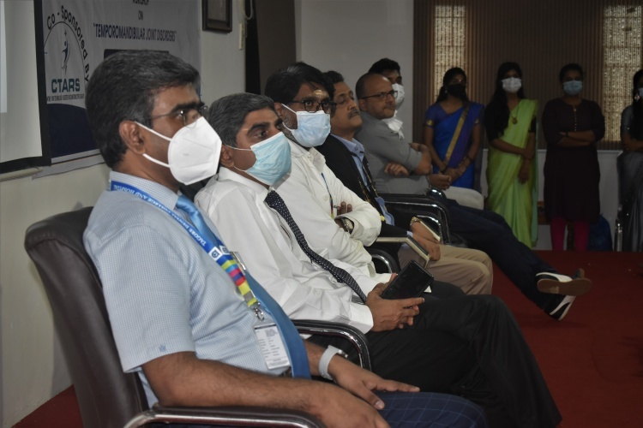
PANNEL DISSCUSSION

